Alter now:

1. Delete if

Delete if country is usa

* Create source
* Click on+select alter row
* Enter alter row

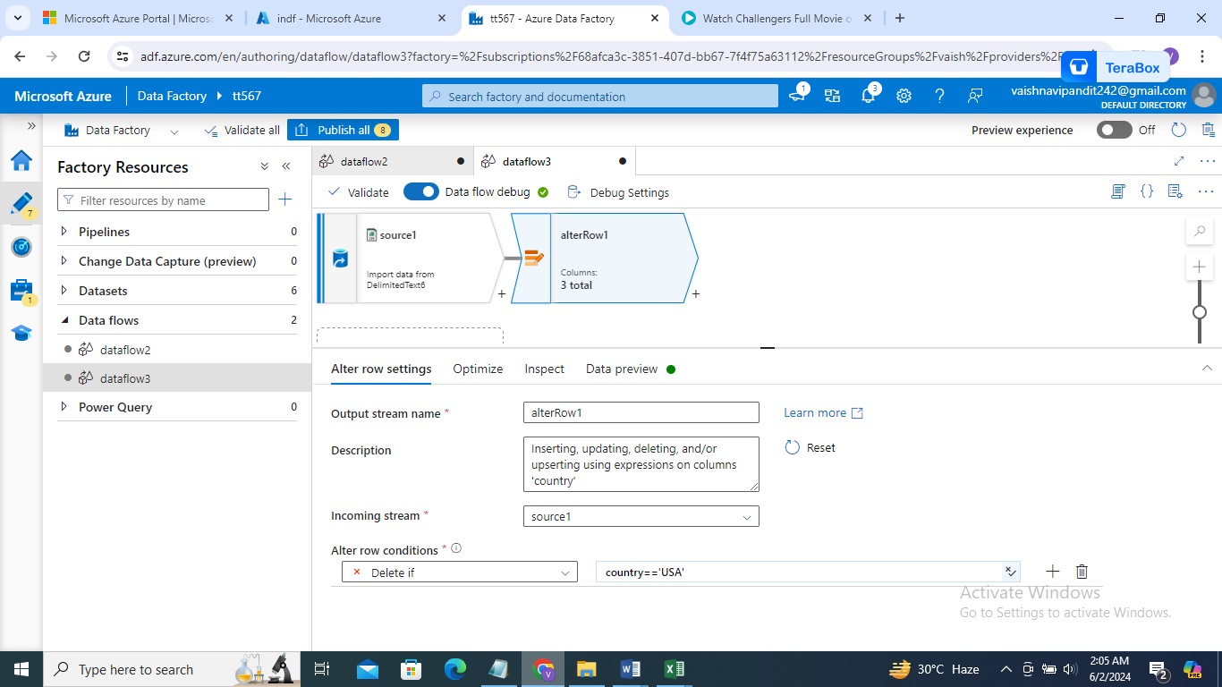

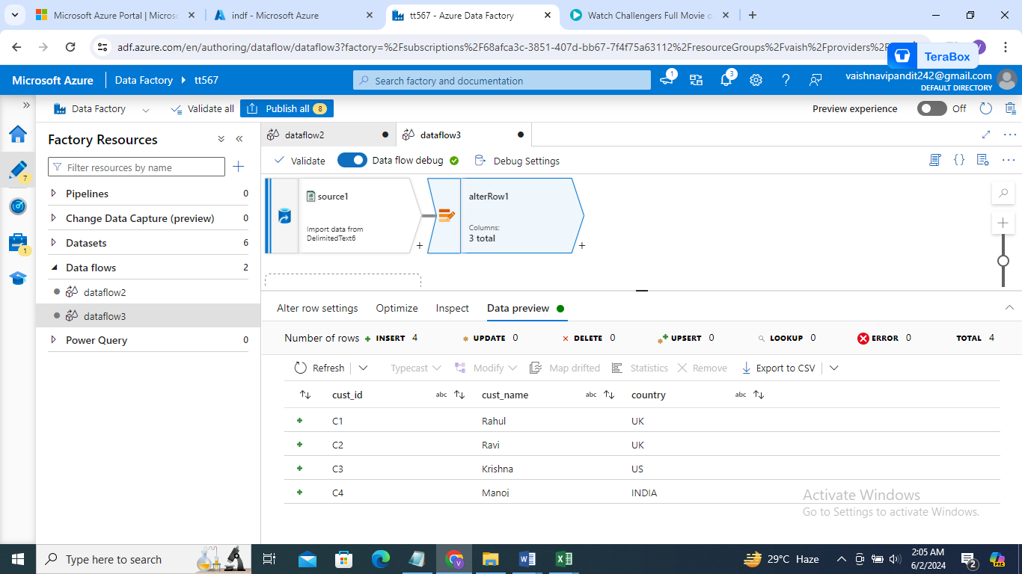

1. -

Create sink for dataset

Go to sink->settings->select allow update

Column= country

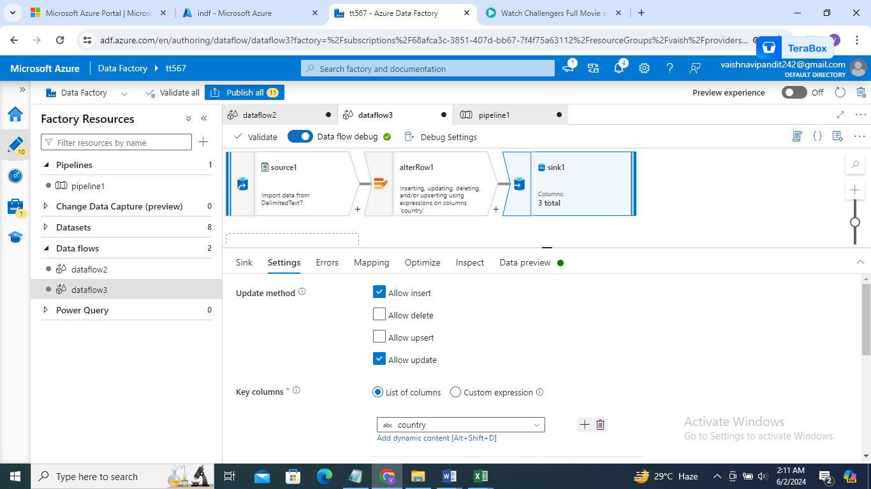

1. Now see output
2. Now I wan to upsert all the records in sink

Select allow upsert in sink settings

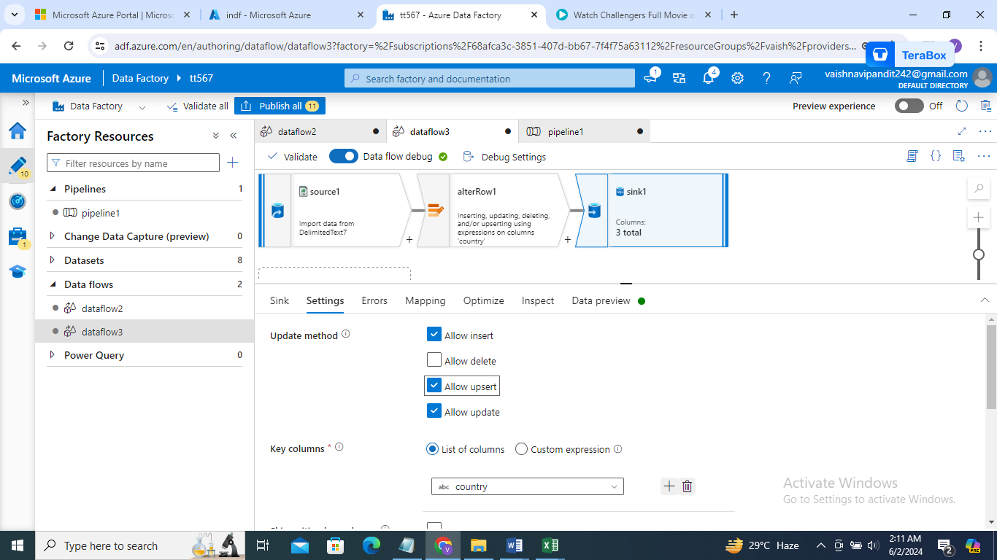

1. Now if I want the data in source to be uploaded in sink but delete the data previously present in table in the

* Create source
* Then create exists create source 2 for sink and add it to the right strem in the exists

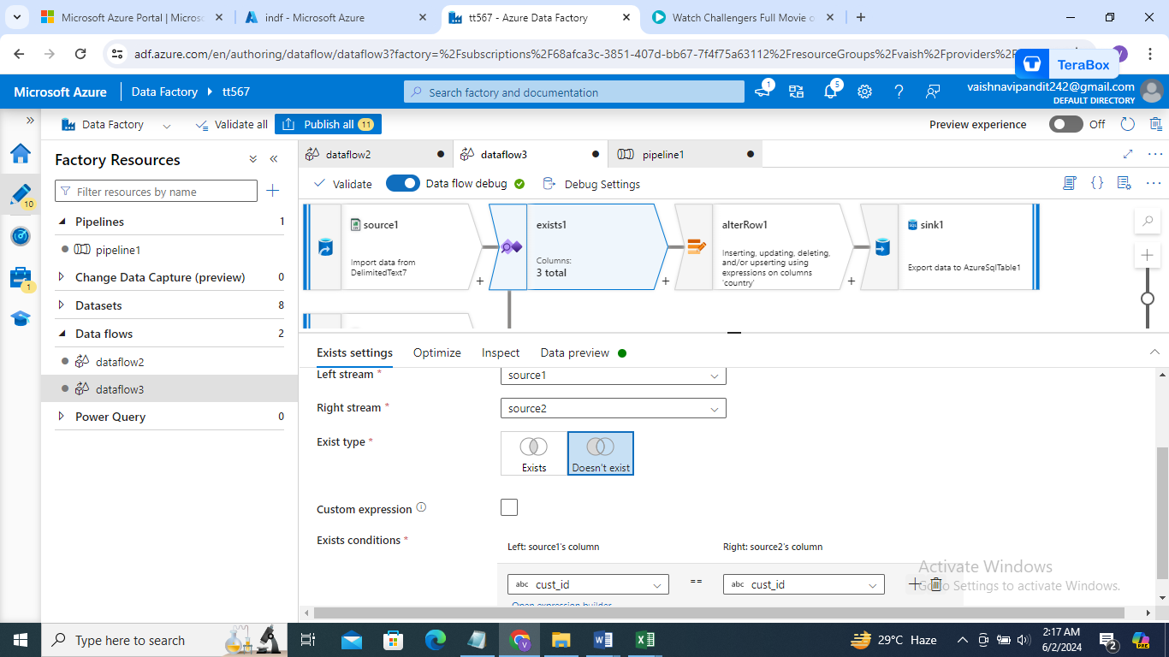

* Now create alter row after exists and add expression delete if true{}

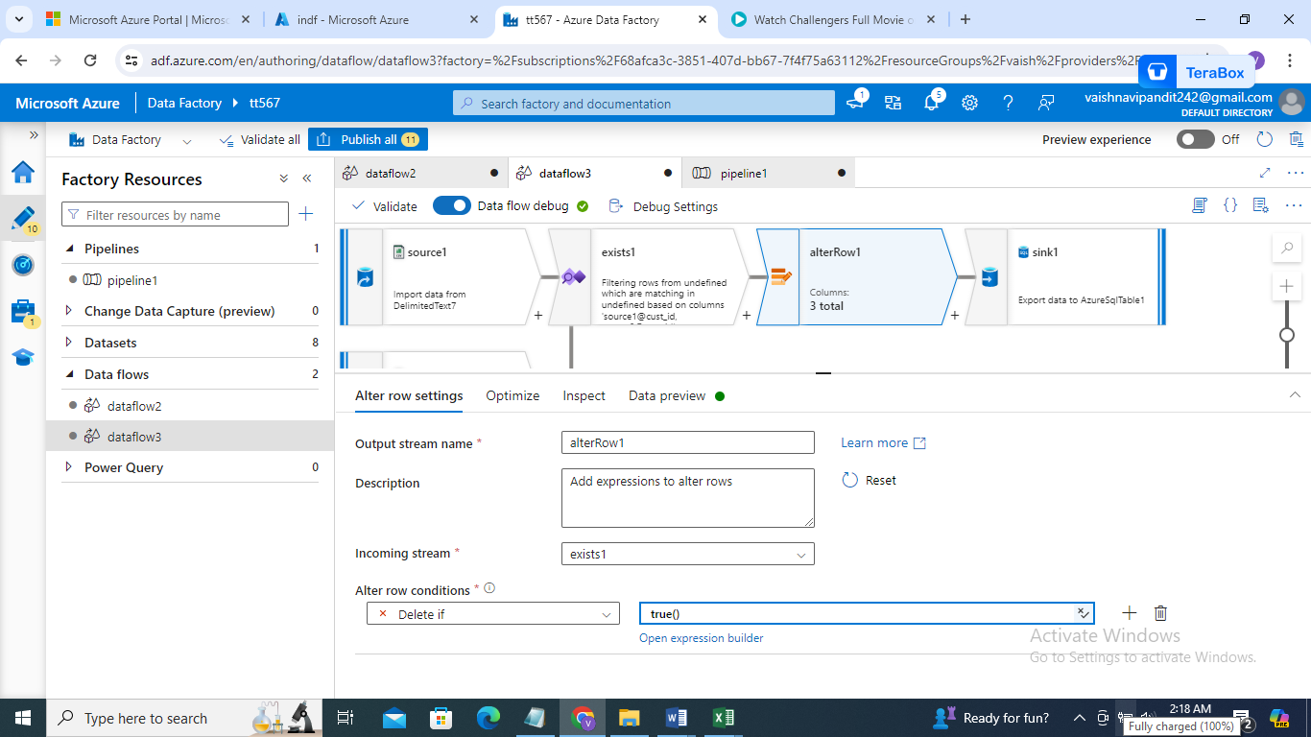

* Now go to sink setting and allow delete

